**Frontend Development with React.js**

**Project Documentation: Nexus News**

**1. Introduction**

Project Title:

Nexus News.

**Team Members and Roles:**

**Team Leader**: Pavithra S

**Email ID**: sac2225cap29@ssacollegechennai.com

**Team Members:**

* **Princy S**

**Email ID**: sac2225cap30@ssacollegechennai.com

* **Priyadharshini M**

**Email ID**: sac2225cap33@ssacollegechennai.com

* **Priyadharshini S**

**Email ID**: sac2225cap32@ssacollegechennai.com

Here's a Medium-style post for your news app project team:

**Team Collaboration:** Building a News App Together

As we embark on this exciting project to build a news app, I want to acknowledge the incredible team behind it. Our collaboration, creativity, and commitment to delivering a top-notch product will make all the difference.

Pavithra S: Project lead and coordinator, ensuring everything runs smoothly and on track.

Priyadharshini M: Expertise in UI/UX design, crafting an intuitive and visually appealing user interface.

Princy S: Skilled developer, handling the app's backend and ensuring seamless functionality.

Priyadharshini S: Research and content specialist, curating relevant and engaging news content for our users.

**Our Goals and Values**

* Deliver a user-friendly and informative news app that meets the highest standards
* Foster open communication, active listening, and mutual respect within the team.
* Embrace challenges, learn from failures, and celebrate successes together.

**2. Project Overview**

**Description:**

globe.jpg Welcome to the forefront of news exploration with Nexus News! Our groundbreaking web application is thoughtfully designed to push the limits of traditional news consumption, catering to the varied interests of both passionate news followers and experienced information seekers. Focused on delivering an intuitive user experience and a comprehensive set of features, Nexus News is set to completely transform how news is discovered and consumed.

images.jfif Crafted with a focus on ease of use and visually appealing design, Nexus News offers users an unmatched journalistic experience. Effortlessly navigate through a wide range of news categories, with powerful tools like dynamic search, bringing you the latest, most relevant stories from across the globe.

 Whether you’re looking for breaking news or diving deep into niche topics, Nexus News serves a broad audience, cultivating a dynamic community united by a shared passion for staying informed. Our goal is to redefine how people interact with news, providing a platform that not only delivers the latest headlines but also fosters collaboration and engagement within a thriving news community.

antenna.jfifJoin us on this exciting journey where innovation blends seamlessly with the best of traditional journalism. Every click within Nexus News brings you closer to global events and diverse viewpoints, all in one place. Experience the future of news consumption—designed with every feature carefully crafted to enhance how we stay informed

**Purpose:**

Nexus News is a web application designed to enhance the way users consume news by offering a seamless, interactive experience. It aggregates news from multiple sources, categorizes content, and provides an advanced search feature for easy navigation.

**Features:**

* Aggregated News from API sources.
* Intuitive and user-friendly interface.
* Powerful search functionality.
* Visually engaging design with categorized news display.
* Subscription feature for daily news updates.

**3. Technical Architecture**

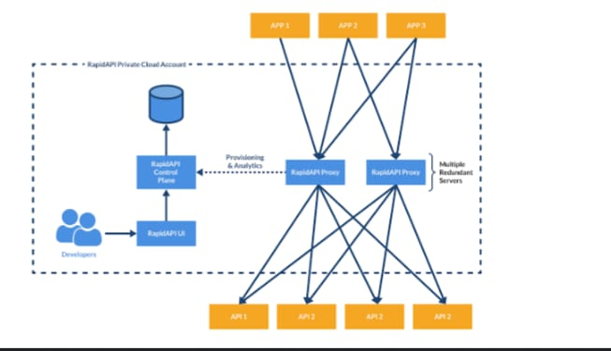

The user journey begins with the Nexus News web application’s interface, which is likely developed using a modern framework like React or Vue.js to ensure a seamless, single-page application experience. The UI communicates with an API client built specifically for Nexus News, which manages the interaction with the backend. What sets it apart is the integration of Rapid API, a platform that connects to a wide range of external APIs.

**Component Structure:**

The project follows a modular React.js component structure:

* Pages Folder: Contains different application pages.
* Components Folder: Stores reusable UI elements.
* Context Folder: Manages application state using Context API.
* Styles Folder: Stores CSS files for styling.

**State Management:**

Uses Context API for global state management and local state handling within components.

**Routing:**

Implemented using React Router Dom for smooth navigation between pages.

**4. Setup Instructions**

**Prerequisites:**

Node.js and npm (Download: <https://nodejs.org/en/download>)

Git for version control (Download: <https://git-scm.com/downloads>)

**Installation:**

1. Clone the repository:  
 git clone repository link  
 cd nexus-news

2. Install dependencies:  
 npm install

3. Start the development server:  
 npm start

**5. Folder Structure**

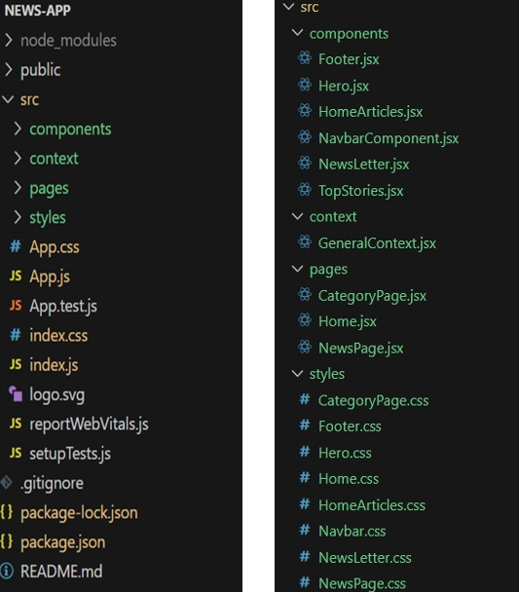

**6. Running the Application**

**Run the frontend server:**  
  
npm start  
  
Access the app at http://localhost:3000

**7. Component Documentation**

* Navbar: Displays navigation links.
* Hero Section: Highlights trending news.
* News Card: Displays individual news articles.

**8. State Management**

* Global State: Managed using Context API.
* Local State: Controlled within individual components.

**9. User Interface**

Screenshots:

* Hero section showcasing trending news

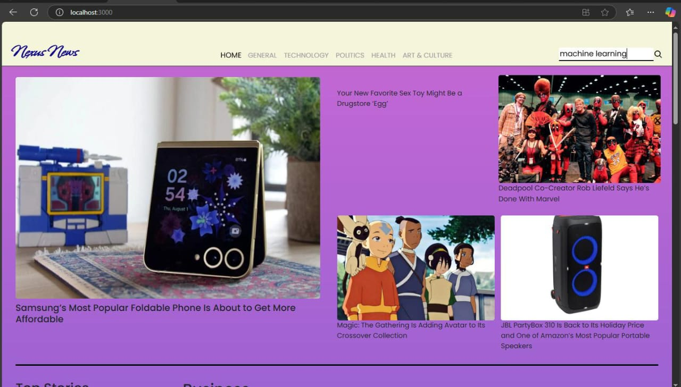

* Category search results page.

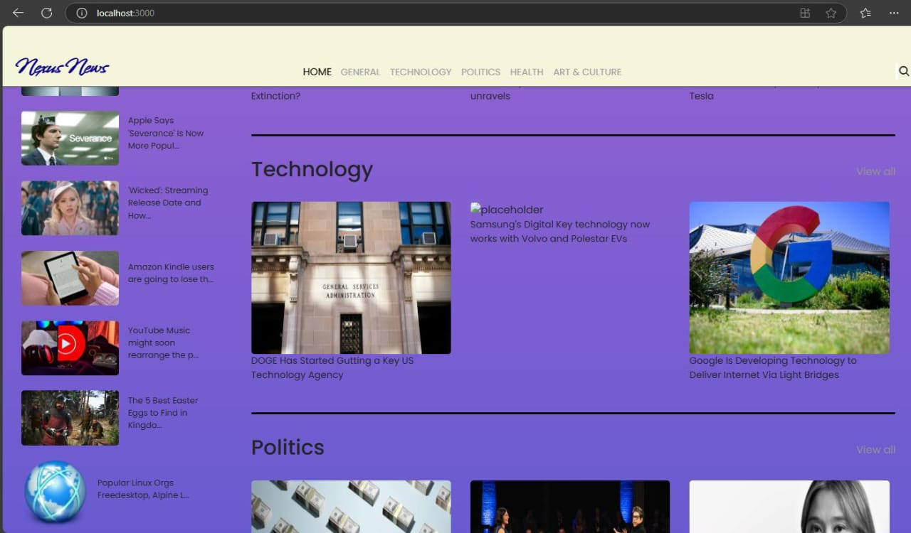

**10. Styling**

* Bootstrap/Tailwind CSS used for UI design.
* React Icons for visual elements.

**11. Testing**

* Jest & React Testing Library used for unit and integration testing.

**12. Screenshots or Demo**

* **Hero component:** The hero component showcases the latest trending news articles, ensuring they stand out. Additionally, it features a search bar, allowing users to quickly search for various articles and categories.

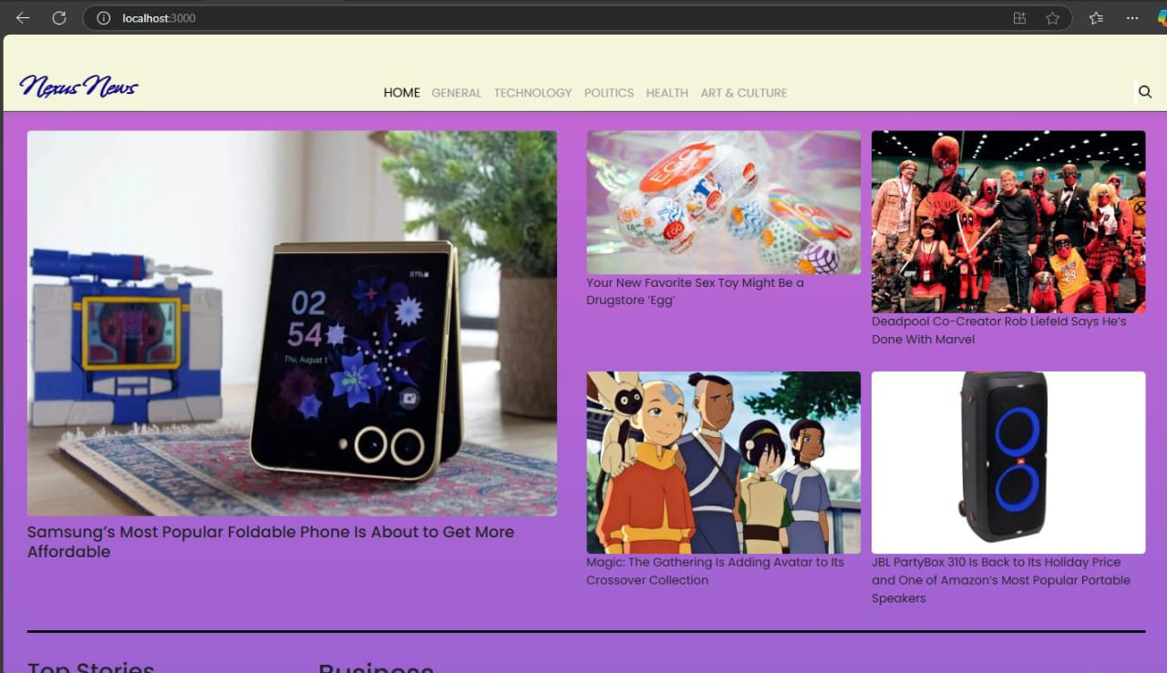

* **Redirected Article Page:** Here’s where you can fully immerse yourself! The article page presents the complete news story, sourced directly from the original provider. To keep you engaged and encourage further exploration, the page may recommend related articles tied to the current topic. These suggestions offer a gateway to a broader range of interconnected information, helping you become a informed and well-rounded reader.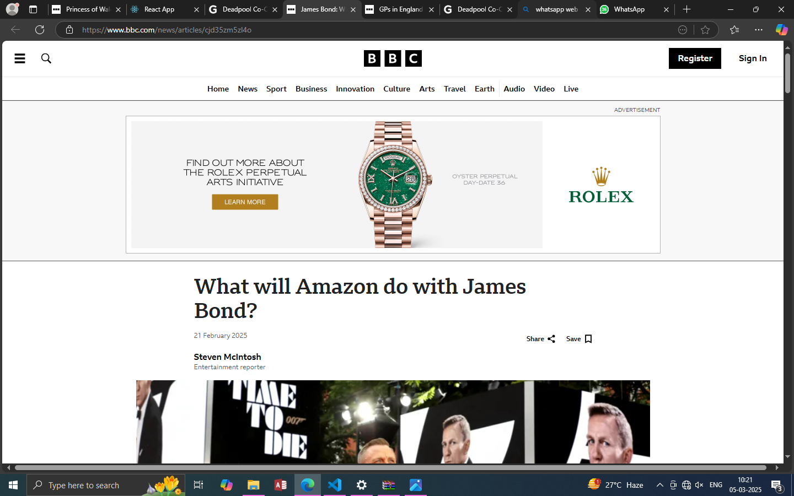
* **Category/Search Result Page:** Discovering the news you’re interested in is a breeze with Nexus News. This page presents a well-organized list of articles that match your selected category or search query. Each article features a clear headline, a brief summary, and, when available, an image to give you a quick preview of the story. To enhance your search, filters or sorting options may be available, allowing you to refine your results.

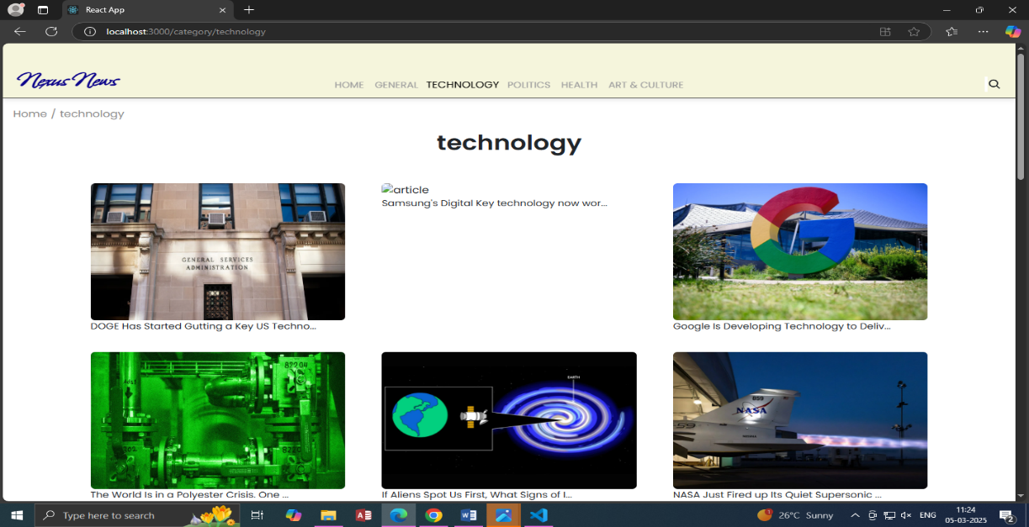

**Newsletter:**

Keeping up with the latest news is essential! This section serves as an invitation for users who wish to stay informed. A concise signup form with an email field will be provided, along with a clear call-to-action button such as "Subscribe Now" or "Receive Daily News Updates." With just one click, users can become part of the Nexus News community and get personalized news.

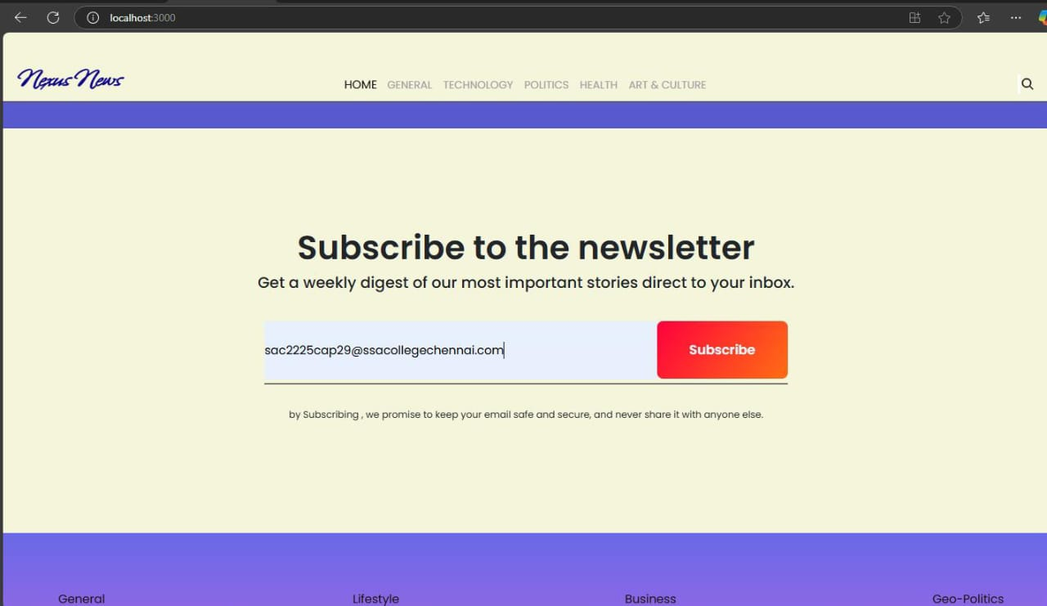

Live Demo [https://drive.google.com/file/d/1npKT9xbdWpH6KnRRdu_VSqrJk7YywiSU/view](%20https:/drive.google.com/file/d/1npKT9xbdWpH6KnRRdu_VSqrJk7YywiSU/view)

**13. Known Issues**

* Some API calls may have rate limits.
* UI improvements needed for better mobile responsiveness.

**14. Future Enhancements**

* User Authentication
* Push Notifications
* Dark Mode

**15. Code Repository**

Use the source code link: [https://drive.google.com/file/d/1QrzXF6dAAoa3rZ9gnRJkKbfqOtt-tf7z/view](%20https:/drive.google.com/file/d/1QrzXF6dAAoa3rZ9gnRJkKbfqOtt-tf7z/view)